Test Case: tc001_SPX_Dev5_Crear_Requisicion_Spot_Tipo_Cobro_CC
Step 1 - Enter username and password and click to button Enter : Credentials Entered
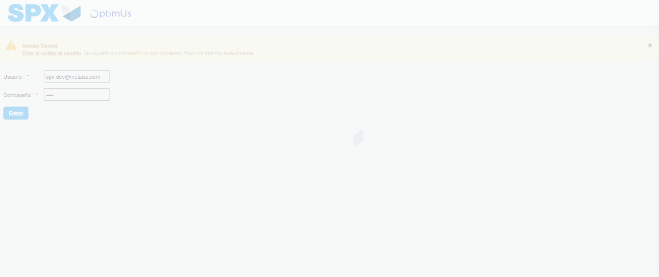Image file-name: QC_Testing-tc001_SPX_Dev5_Crear_Requisicion_Spot_Tipo_Cobro_CC-1784569066761

Step 2 - Select to UEN and Access to Spot Buy Requisitions : UEN Correctly selected and Correct access
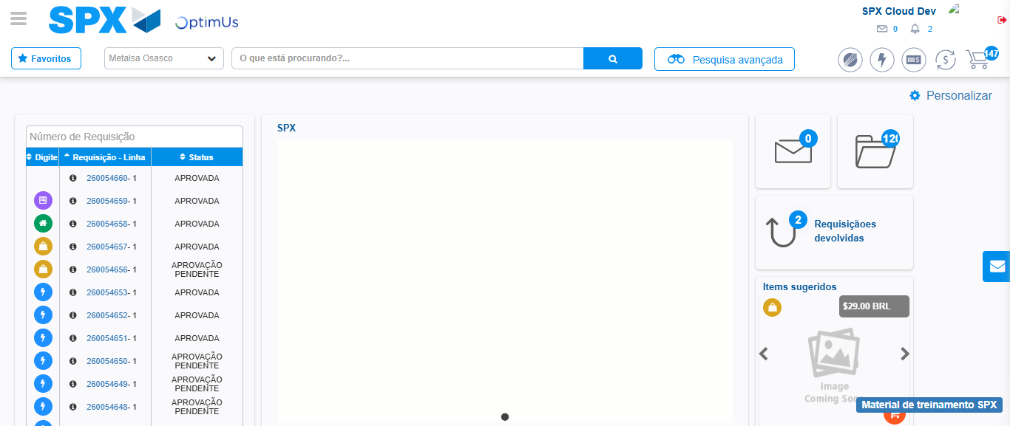Image file-name: QC_Testing-tc001_SPX_Dev5_Crear_Requisicion_Spot_Tipo_Cobro_CC-1784569135640

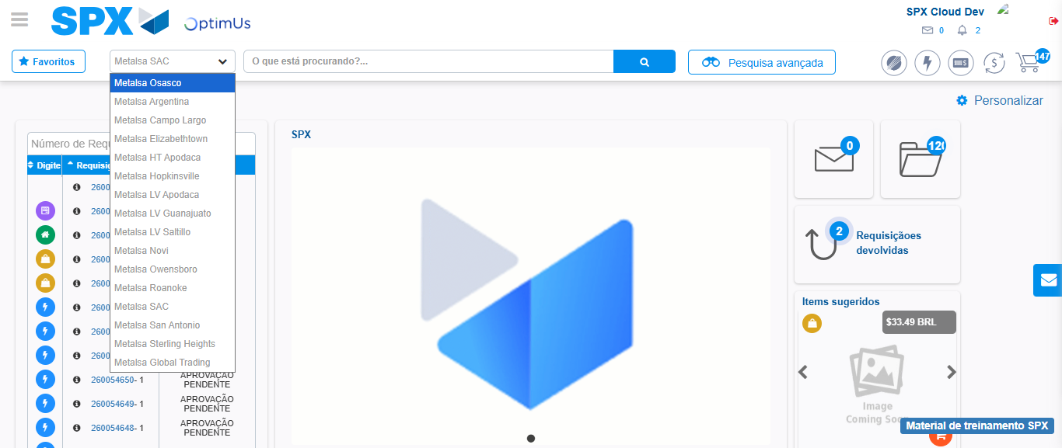Image file-name: QC_Testing-tc001_SPX_Dev5_Crear_Requisicion_Spot_Tipo_Cobro_CC-1784569138423

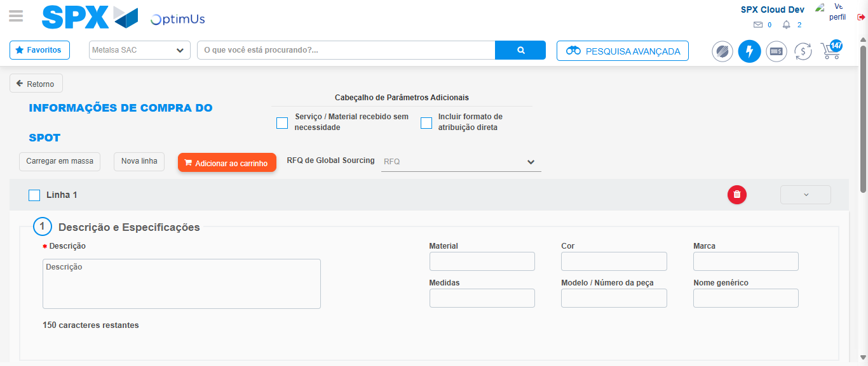Image file-name: QC_Testing-tc001_SPX_Dev5_Crear_Requisicion_Spot_Tipo_Cobro_CC-1784569150756

Step 3 - Data Capture Spot Buy Requisition : Data captured correctly
Image file-name: QC_Testing-tc001_SPX_Dev5_Crear_Requisicion_Spot_Tipo_Cobro_CC-1784569151046

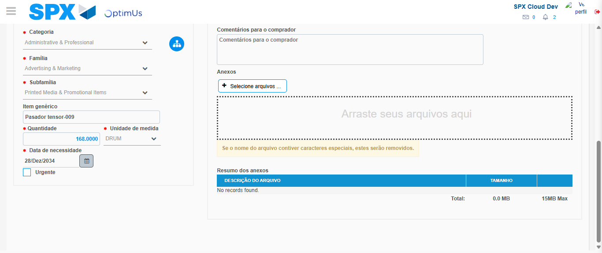Image file-name: QC_Testing-tc001_SPX_Dev5_Crear_Requisicion_Spot_Tipo_Cobro_CC-1784569163749

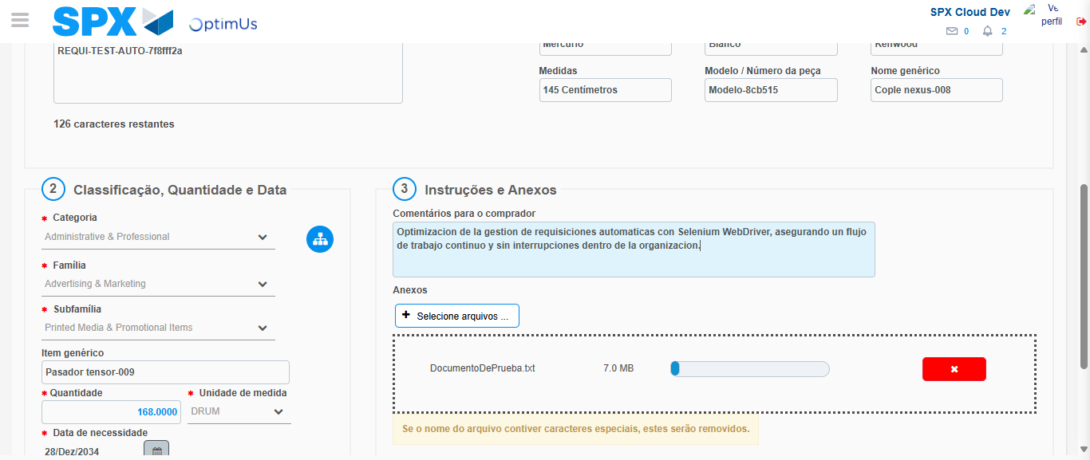Image file-name: QC_Testing-tc001_SPX_Dev5_Crear_Requisicion_Spot_Tipo_Cobro_CC-1784569164652

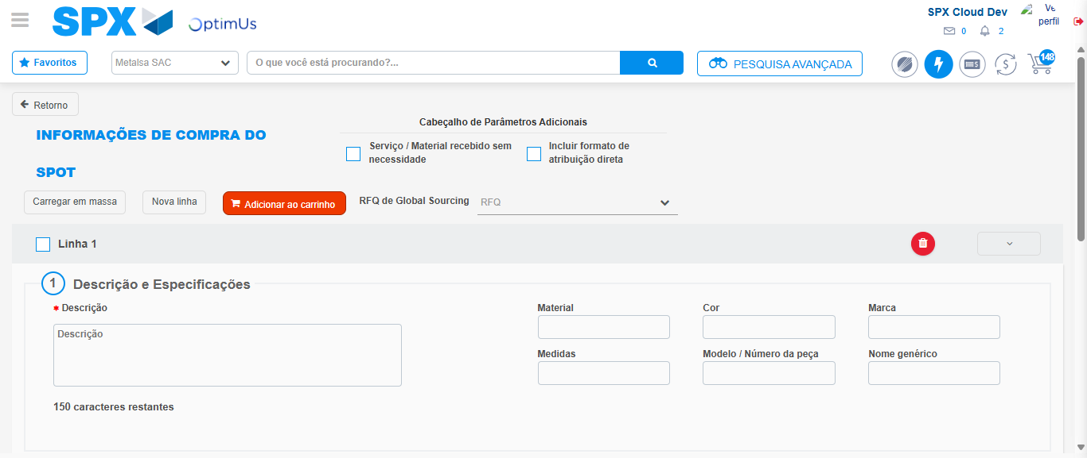Image file-name: QC_Testing-tc001_SPX_Dev5_Crear_Requisicion_Spot_Tipo_Cobro_CC-1784569180793

Step 7 - Return to Main Page SPX : Return to Main Page SPX
Image file-name: QC_Testing-tc001_SPX_Dev5_Crear_Requisicion_Spot_Tipo_Cobro_CC-1784569135640

Image file-name: QC_Testing-tc001_SPX_Dev5_Crear_Requisicion_Spot_Tipo_Cobro_CC-1784569138423

Image file-name: QC_Testing-tc001_SPX_Dev5_Crear_Requisicion_Spot_Tipo_Cobro_CC-1784569150756

Image file-name: QC_Testing-tc001_SPX_Dev5_Crear_Requisicion_Spot_Tipo_Cobro_CC-1784569183056

Image file-name: QC_Testing-tc001_SPX_Dev5_Crear_Requisicion_Spot_Tipo_Cobro_CC-1784569183252

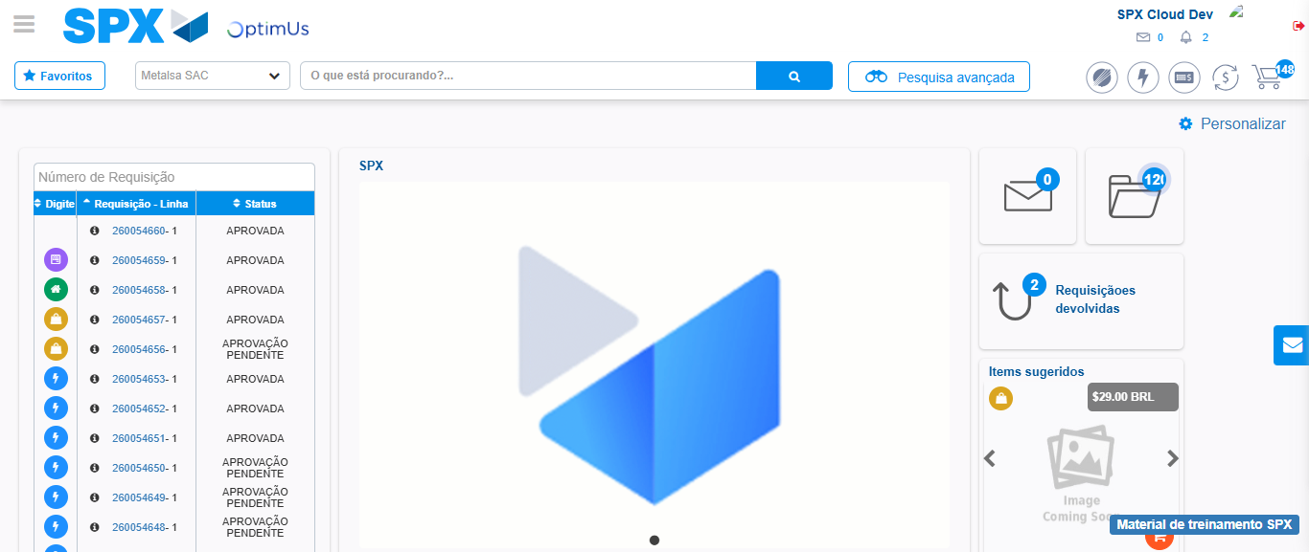Image file-name: QC_Testing-tc001_SPX_Dev5_Crear_Requisicion_Spot_Tipo_Cobro_CC-1784569204541

Step 8 - Log Out : Log Out SPX
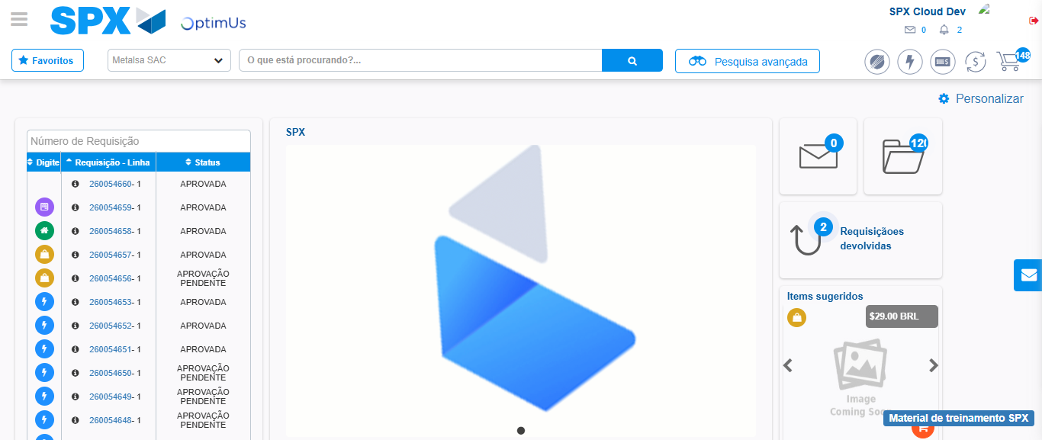Image file-name: QC_Testing-tc001_SPX_Dev5_Crear_Requisicion_Spot_Tipo_Cobro_CC-1784569204880

